Phase 4

Product Sales Analysis

To determine that using IBM Cognos to design interactive dashboards and report that displays the insights such as top-selling products, sales trends, and customer preferences.

Import pandas as pd

df = pd.read_csv()

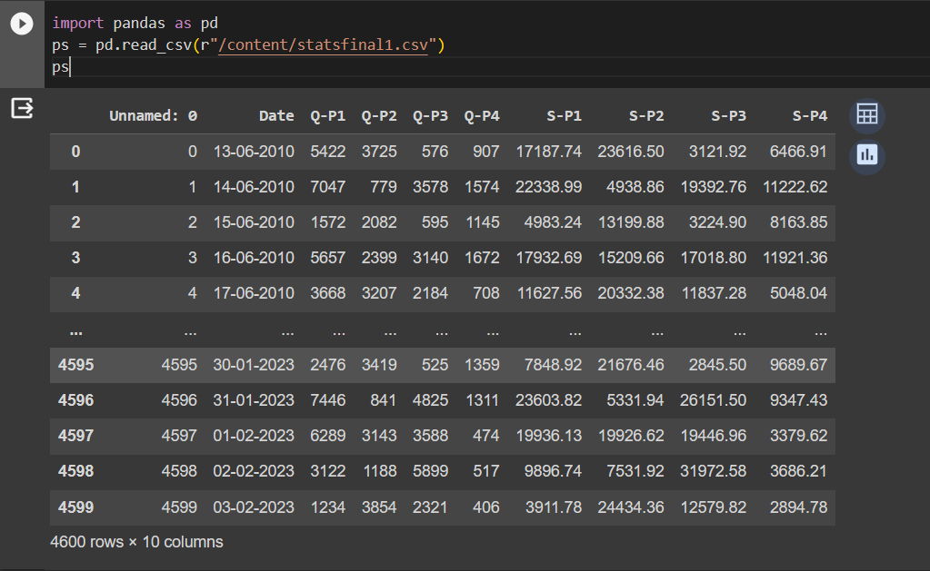

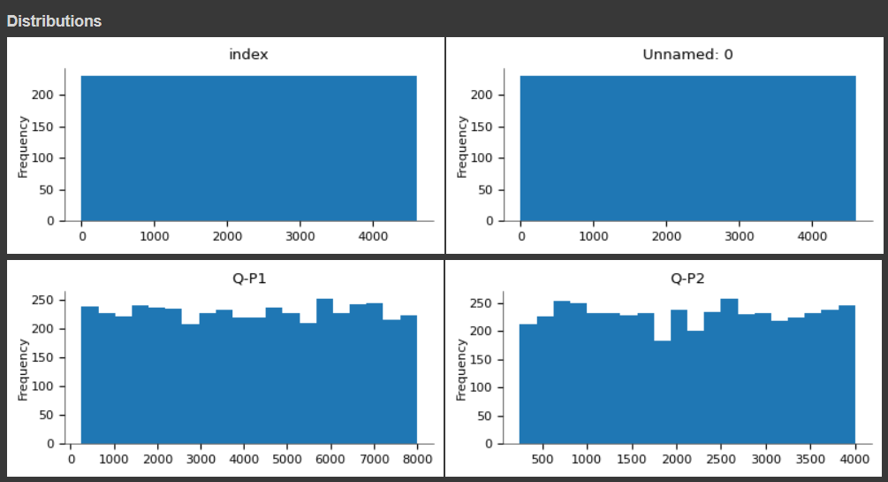

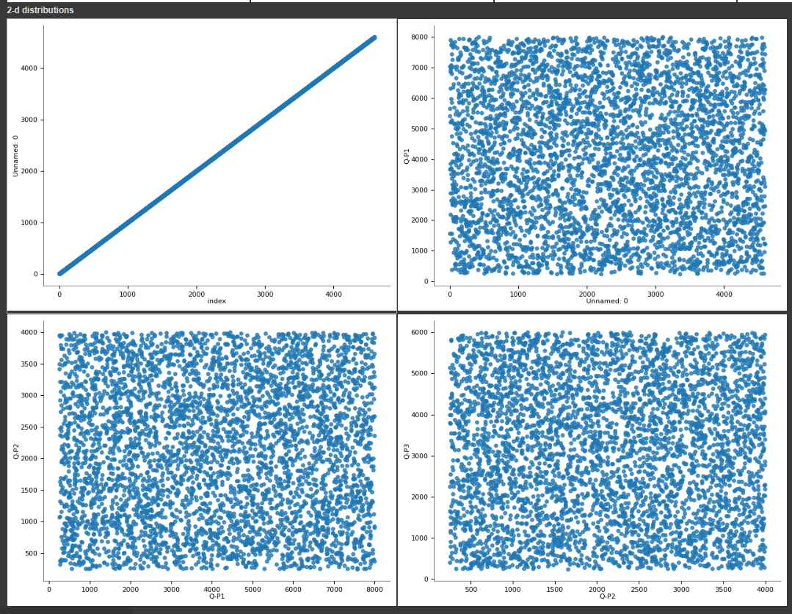

Visualization insights for product sales analysis dataset using python. These are the outputs for the given dataset.

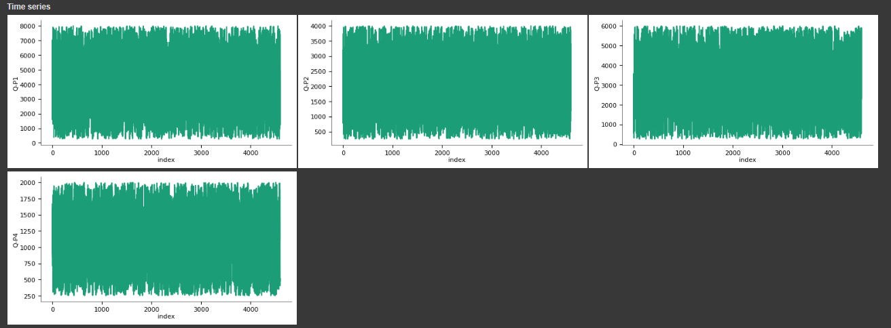

1.Peak Sales Periods:

To calculate the peak sales product in dataset using Python, we need to analyze a dataset that information about products and their sales.

Assuming the DataFrame has a column product name and a column sales name for sales figures, we can find the product with the highest peak sales using the following code:

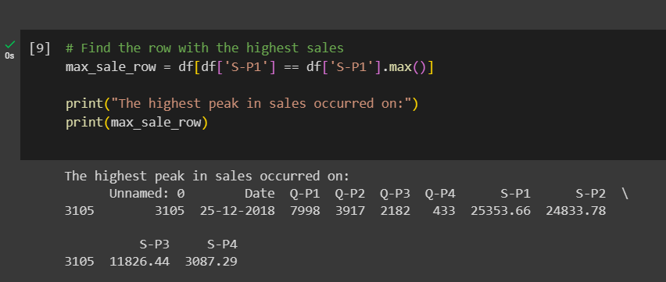

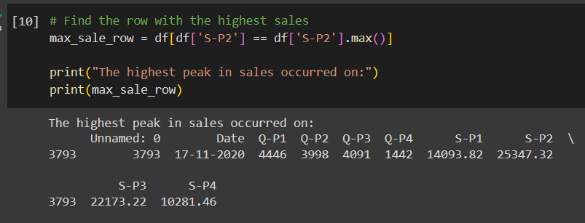

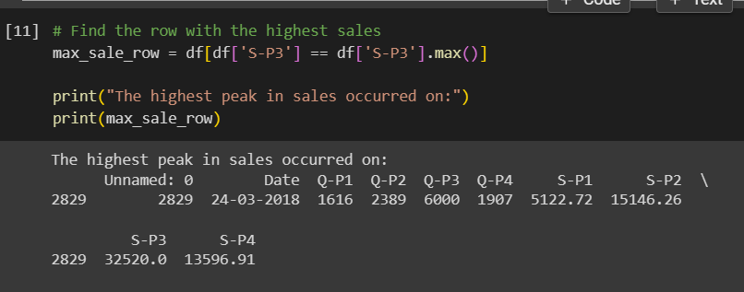

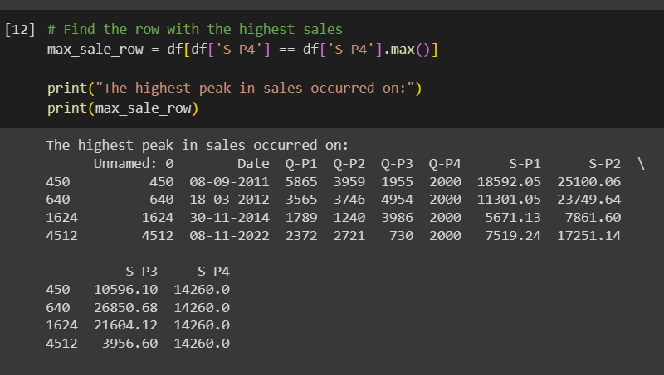

2.Highest Sales:

Using Python programming we calculating the Highest peak in a product sales dataset. We need to analyze the dataset and identify the points with the highest sales. Here’s a we convert the dataset into a pandas DataFrame for easier data manipulation.

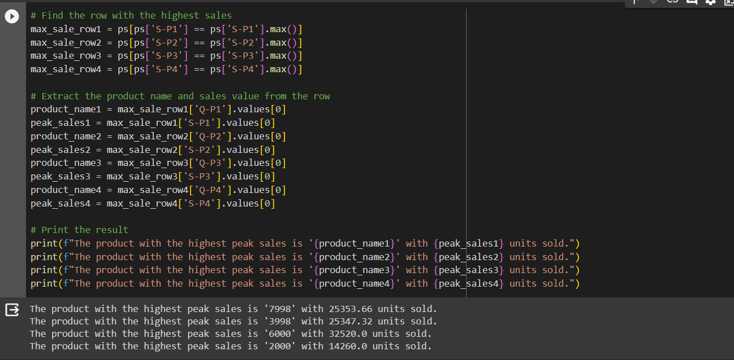

3.Customer Preferences:

Customer preferences can be determined in various ways, depending on the nature of the dataset. We will calculate customer preferences based on the number of purchases with specific products in a dataset using python.

Assuming the DataFrame has the columns for the customer and multiple preferences attributes, We can calculate customer preferences by summing or aggregating the values across these attributes:

